Part I: The Objective-C Language
2. Programming in Objective-C
In this chapter, we dive right in and show you how to write your first Objective-C program. You won’t work with objects just yet; that’s the topic of the next chapter. We want you to understand the steps involved in keying in a program and compiling and running it.
To begin, let’s pick a rather simple example: a program that displays the phrase “Programming is fun!” on your screen. Without further ado, Program 2.1 shows an Objective-C program to accomplish this task..
Program 2.1
Click here to view code image

// First program example
#import <Foundation/Foundation.h>
int main (int argc, const char * argv[])
{
@autoreleasepool {
NSLog (@"Programming is fun!");
}
return 0;
}

Compiling and Running Programs
Before we go into a detailed explanation of this program, we need to cover the steps involved in compiling and running it. You can both compile and run your program using Xcode, or you can use the Clang Objective-C compiler in a Terminal window. Let’s go through the sequence of steps using both methods. Then you can decide how you want to work with your programs throughout the rest of this book.

Note
Xcode is available from the Mac App Store. However, you can also get pre-release versions of Xcode by becoming a registered Apple developer (no charge for that). Go tohttp://developer.apple.com to get the latest version of the Xcode development tools. There you can download Xcode and the iOS software development kit (SDK) for no charge.

Using Xcode
Xcode is a sophisticated application that enables you to easily type in, compile, debug, and execute programs. If you plan on doing serious application development on the Mac, learning how to use this powerful tool is worthwhile. We just get you started here. Later we return to Xcode and take you through the steps involved in developing a graphical application with it.

Note
As mentioned, Xcode is a sophisticated tool, and the introduction of Xcode 4 added even more features. It’s easy to get lost using this tool. If that happens to you, back up a little and try reading the Xcode User Guide, which you can access from the Xcode Help menu, to get your bearings.

Once installed, Xcode is in your Applications folder. Figure 2.1 shows its icon.
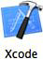
Figure 2.1. Xcode icon
Start Xcode. (The first time you launch the application, you have to go through some one-time things like agreeing to the license agreement.) You can then select Create a New Xcode Project from the startup screen (see Figure 2.2). Alternatively, under the File menu, select New, Project.
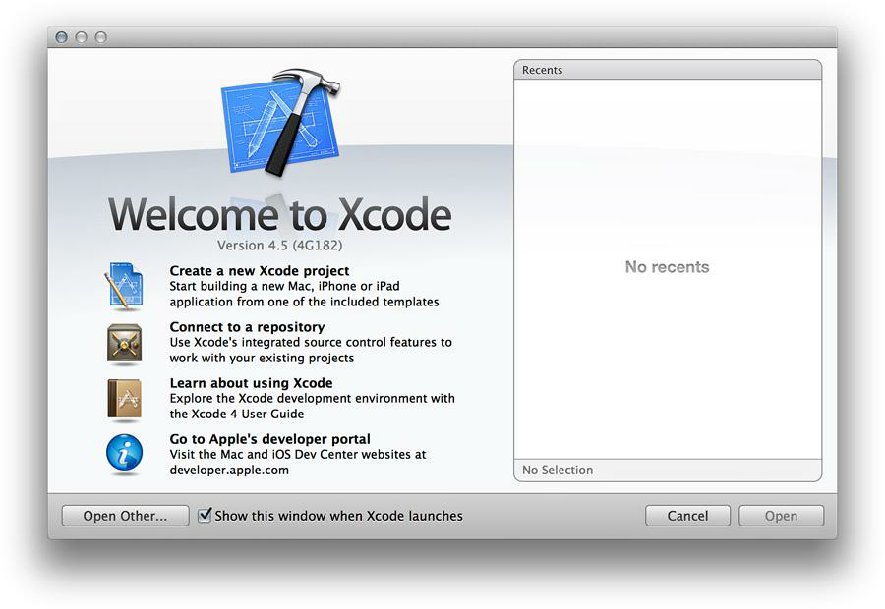
略去，用时再说 。。。 Jasper Li

Using Terminal
Some people might want to avoid having to learn Xcode to get started programming with Objective-C. If you’re used to using the UNIX shell and command-line tools, you might want to edit, compile, and run your programs using the Terminal application. Here, we examine how to go about doing that.
Before attempting to compile you program from the command line, make sure that you have Xcode’s Command Line Tools installed on your system. Go to Xcode, Preferences, Downloads, Components from inside Xcode. You’ll see something similar to Figure 2.10. This figure indicates that the Command Line Tools have not been installed on this system. To do so, you click the Install button..
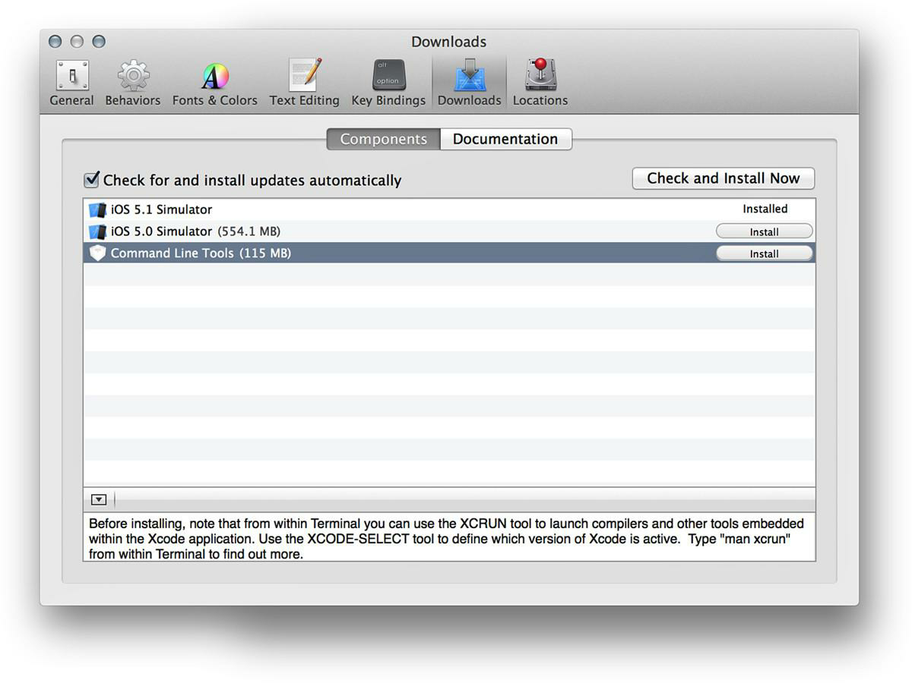
Figure 2.10. Installing the Command Line Tools
Once the Command Line Tools have been installed, the next step is to start the Terminal application on your Mac. The Terminal application is located in the Applications folder, stored under Utilities. Figure 2.11 shows its icon.

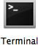

Figure 2.11. Terminal program icon
Start the Terminal application. You’ll see a window that looks like Figure 2.12.
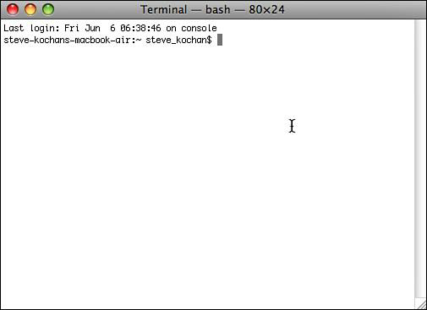
Figure 2.12. Terminal window
You type commands after the $ (or %, depending on how your Terminal application is configured) on each line. If you’re familiar with using UNIX, you’ll find this straightforward.
First, you need to enter the lines from Program 2.1 into a file. You can begin by creating a directory in which to store your program examples. Then, you must run a text editor, such as vi or emacs, to enter your program:
sh-2.05a$ mkdir Progs Create a directory to store programs in
sh-2.05a$ cd Progs Change to the new directory
sh-2.05a$ vi main.m Start up a text editor to enter program
--

Note
In the previous example and throughout the remainder of this text, commands that you, the user, enter are indicated in boldface.

For Objective-C files, you can choose any name you want; just make sure that the last two characters are .m. This indicates to the compiler that you have an Objective-C program.
After you’ve entered your program into a file (and we’re not showing the edit commands to enter and save your text here) and have verified that you have the right tools installed, you can use the LLVM Clang Objective-C compiler, which is called clang, to compile and link your program. This is the general format of the clang command:
clang -fobjc-arc files -o program
files is the list of files to be compiled. In this example, we have only one such file, and we’re calling it main.m. program is the name of the file that will contain the executable if the program compiles without any errors.
We’ll call the program prog1; here, then, is the command line to compile your first Objective-C program:
$ clang -fobjc-arc main.m -o prog1 Compile main.m & call it prog1
$
The return of the command prompt without any messages means that no errors were found in the program. Now you can subsequently execute the program by typing the name prog1 at the command prompt:
$ prog1 Execute prog1
sh: prog1: command not found
$
This is the result you’ll probably get unless you’ve used Terminal before. The UNIX shell (which is the application running your program) doesn’t know where prog1 is located (we don’t go into all the details of this here), so you have two options: One is to precede the name of the program with the characters ./ so that the shell knows to look in the current directory for the program to execute. The other is to add the directory in which your programs are stored (or just simply the current directory) to the shell’s PATH variable. Let’s take the first approach here:
$ ./prog1 Execute prog1
2012-09-03 18:48:44.210 prog1[7985:10b] Programming is fun!
$
Note that writing and debugging Objective-C programs from the Terminal is a valid approach. However, it’s not a good long-term strategy. If you want to build OS X or iOS applications, there’s more to just the executable file that needs to be “packaged” into an application bundle. It’s not easy to do that from the Terminal application, and it’s one of Xcode’s specialties. Therefore, I suggest you start learning to use Xcode to develop your programs. There is a learning curve to do this, but the effort will be well worth it in the end.

Explanation of Your First Program
Now that you are familiar with the steps involved in compiling and running Objective-C programs, let’s take a closer look at this first program. Here it is again:
// First program example
#import <Foundation/Foundation.h>
int main (int argc, const char * argv[])
{
@autoreleasepool {
NSLog (@"Programming is fun!");
}
return 0;
}
In Objective-C, lowercase and uppercase letters are distinct. Also, Objective-C doesn’t care where on the line you begin typing—you can begin typing your statement at any position on the line. You can use this to your advantage in developing programs that are easier to read.
The first seven lines of the program introduce the concept of the comment. A comment statement is used in a program to document a program and enhance its readability. Comments tell the reader of the program—whether it’s the programmer or someone else whose responsibility it is to maintain the program—just what the programmer had in mind when writing a particular program or a particular sequence of statements.
You can insert comments into an Objective-C program in two ways. One is by using two consecutive slash characters (//). The compiler ignores any characters that follow these slashes, up to the end of the line.
You can also initiate a comment with the two characters / and *. This marks the beginning of the comment. These types of comments have to be terminated. To end the comment, you use the characters * and /, again without any embedded spaces. All characters included between the opening /* and the closing */ are treated as part of the comment statement and are ignored by the Objective-C compiler. This form of comment is often used when comments span many lines of code, as in the following:
Click here to view code image
/*
This file implements a class called Fraction, which
represents fractional numbers. Methods allow manipulation of
fractions, such as addition, subtraction, etc.
For more information, consult the document:
/usr/docs/classes/Fraction.pdf
*/
Which style of comment you use is entirely up to you. Just note that you cannot nest the /* style comments.
Get into the habit of inserting comment statements in the program as you write it or type it into the computer, for three good reasons. First, documenting the program while the particular program logic is still fresh in your mind is much easier than going back and rethinking the logic after the program has been completed. Second, by inserting comments into the program at such an early stage of the game, you can reap the benefits of the comments during the debug phase, when program logic errors are isolated and debugged. Not only can a comment help you (and others) read through the program, but it can also help point the way to the source of the logic mistake. Finally, I haven’t yet discovered a programmer who actually enjoys documenting a program. In fact, after you’ve finished debugging your program, you will probably not relish the idea of going back to the program to insert comments. Inserting comments while developing the program makes this sometimes-tedious task a bit easier to handle.
This next line of Program 2.1 tells the compiler to locate and process a file named Foundation.h:
#import <Foundation/Foundation.h>
This is a system file—that is, not a file that you created. #import says to import or include the information from that file into the program, exactly as if the contents of the file were typed into the program at that point. You imported the file Foundation.h because it has information about other classes and functions that are used later in the program.
In Program 2.1, this line specifies that the name of the program is main:
int main (int argc, const char * argv[])
main is a special name that indicates precisely where the program is to begin execution. The reserved word int that precedes main specifies the type of value main returns, which is an integer (more about that soon). We ignore what appears between the open and closed parentheses for now; these have to do with command-line arguments, a topic we address in Chapter 13, “Underlying C Language Features.”
Now that you have identified main to the system, you are ready to specify precisely what this routine is to perform. This is done by enclosing all the program statements of the routine within a pair of curly braces. In the simplest case, a statement is just an expression that is terminated with a semicolon. The system treats all the program statements included between the braces as part of the main routine.
The next line in main reads as follows:
@autoreleasepool {
Any program statements between the { and the matching closing } are executed within a context known an autorelease pool. The autorelease pool is a mechanism that allows the system to efficiently manage the memory your application uses as it creates new objects. I mention it in more detail in Chapter 17, “Memory Management and Automatic Reference Counting.” Here, we have one statement inside our @autoreleasepool context.
That statement specifies that a routine named NSLog is to be invoked, or called. The parameter, or argument, to be passed or handed to the NSLog routine is the following string of characters:
@"Programming is fun!"
Here, the @ sign immediately precedes a string of characters enclosed in a pair of double quotes. Collectively, this is known as a constant NSString object.

Note
If you have C programming experience, you might be puzzled by the leading @ character. Without that leading @ character, you are writing a constant C-style string; with it, you are writing an NSString string object. More on this topic in Chapter 15, “Numbers, Strings, and Collections.”

The NSLog routine is a function that simply displays or logs its argument (or arguments, as you will see shortly). Before doing so, however, it displays the date and time the routine is executed, the program name, and some other numbers not described here. Throughout the rest of this book, we don’t bother to show this text that NSLog inserts before your output.
You must terminate all program statements in Objective-C with a semicolon (;). This is why a semicolon appears immediately after the closed parenthesis of the NSLog call.
The final program statement in main looks like this:
return 0;
It says to terminate execution of main and to send back, or return, a status value of 0. By convention, 0 means that the program ended normally. Any nonzero value typically means some problem occurred; for example, perhaps the program couldn’t locate a file that it needed.
Now that you have finished discussing your first program, let’s modify it to also display the phrase “And programming in Objective-C is even more fun!” You can do this by simply adding another call to the NSLog routine, as shown in Program 2.2. Remember that every Objective-C program statement must be terminated by a semicolon. Note that we’ve removed the leading comment lines in all the following program examples.

Program 2.2
Click here to view code image

#import <Foundation/Foundation.h>
int main (int argc, const char * argv[])
{
@autoreleasepool {
NSLog (@"Programming is fun!");
NSLog (@"Programming in Objective-C is even more fun!");
}
return 0;
}

If you type in Program 2.2 and then compile and execute it, you can expect the following output (again, without showing the text that NSLog normally prepends to the output).
Program 2.2. Output

Programming is fun!
Programming in Objective-C is even more fun!

As you will see from the next program example, you don’t need to make a separate call to the NSLog routine for each line of output.
First, let’s talk about a special two-character sequence. The backslash (\) and the letter n are known collectively as the newline character. A newline character tells the system to do precisely what its name implies: go to a new line. Any characters to be printed after the newline character then appear on the next line of the display. In fact, the newline character is very similar in concept to the carriage return key on a typewriter (remember those?).
Study the program listed in Program 2.3 and try to predict the results before you examine the output (no cheating, now!).
Program 2.3.

#import <Foundation/Foundation.h>
int main (int argc, const char *argv[])
{
@autoreleasepool {
NSLog (@"Testing...\n..1\n...2\n....3");
}
return 0;
}

Program 2.3. Output

Testing...
..1
...2
....3

Displaying the Values of Variables
Not only can simple phrases be displayed with NSLog, but the values of variables and the results of computations can be displayed as well. Program 2.4 uses the NSLog routine to display the results of adding two numbers, 50 and 25.
Program 2.4.
Click here to view code image

#import <Foundation/Foundation.h>
int main (int argc, const char *argv[])
{
@autoreleasepool {
int sum;
sum = 50 + 25;
NSLog (@"The sum of 50 and 25 is %i", sum);
}
return 0;
}

Program 2.4. Output

The sum of 50 and 25 is 75

The first program statement inside main after the autorelease pool is set up defines the variable sum to be of type integer. You must define all program variables before you can use them in a program. The definition of a variable specifies to the Objective-C compiler how the program should use it. The compiler needs this information to generate the correct instructions to store and retrieve values into and out of the variable. A variable defined as type int can be used to hold only integral values—that is, values without decimal places. Examples of integral values are 3, 5, –20, and 0. Numbers with decimal places, such as 2.14, 2.455, and 27.0, are known as floating-point numbers and are real numbers.
The integer variable sum stores the result of the addition of the two integers 50 and 25. We have intentionally left a blank line following the definition of this variable to visually separate the variable declarations of the routine from the program statements; this is strictly a matter of style. Sometimes adding a single blank line in a program can make the program more readable.
The program statement reads as it would in most other programming languages:
sum = 50 + 25;
The number 50 is added (as indicated by the plus sign) to the number 25, and the result is stored (as indicated by the assignment operator, the equals sign) in the variable sum.
The NSLog routine call in Program 2.4 now has two arguments enclosed within the parentheses. These arguments are separated by a comma. The first argument to the NSLog routine is always the character string to be displayed. However, along with the display of the character string, you often want to have the value of certain program variables displayed as well. In this case, you want to have the value of the variable sum displayed after these characters are displayed:
The sum of 50 and 25 is
The percent character inside the first argument is a special character recognized by the NSLog function. The character that immediately follows the percent sign specifies what type of value is to be displayed at that point. In the previous program, the NSLog routine recognizes the letter i as signifying that an integer value is to be displayed.
Whenever the NSLog routine finds the %i characters inside a character string, it automatically displays the value of the next argument to the routine. Because sum is the next argument to NSLog, its value is automatically displayed after “The sum of 50 and 25 is.”
Now try to predict the output from Program 2.5.
Program 2.5.
Click here to view code image

#import <Foundation/Foundation.h>
int main (int argc, const char *argv[])
{
@autoreleasepool {
int value1, value2, sum;
value1 = 50;
value2 = 25;
sum = value1 + value2;
NSLog (@"The sum of %i and %i is %i", value1, value2, sum);
}
return 0;
}

Program 2.5. Output

The sum of 50 and 25 is 75

The second program statement inside main defines three variables called value1, value2, and sum, all of type int. This statement could have equivalently been expressed using three separate statements, as follows:
int value1;
int value2;
int sum;
After the three variables have been defined, the program assigns the value 50 to the variable value1 and then the value 25 to value2. The sum of these two variables is then computed and the result assigned to the variable sum.
The call to the NSLog routine now contains four arguments. Once again, the first argument, commonly called the format string, describes to the system how the remaining arguments are to be displayed. The value of value1 displays immediately following the phrase “The sum of.” Similarly, the values of value2 and sum will print at the points indicated by the next two occurrences of the %i characters in the format string.
Summary
After reading this introductory chapter on developing programs in Objective-C, you should have a good feel about what is involved in writing a program in Objective-C—and you should be able to develop a small program on your own. In the next chapter, you begin to examine some of the intricacies of this powerful and flexible programming language. But first, try your hand at the exercises that follow, to make sure you understand the concepts presented in this chapter.
Exercises
1. Type in and run the five programs presented in this chapter. Compare the output produced by each program with the output presented after each program.
2. Write a program that displays the following text:
Click here to view code image
In Objective-C, lowercase letters are significant.
main is where program execution begins.
Open and closed braces enclose program statements in a routine.
All program statements must be terminated by a semicolon.
3. What output would you expect from the following program?
Click here to view code image
#import <Foundation/Foundation.h>
int main (int argc, const char * argv[])
{
@autoreleasepool {
int i;
i = 1;
NSLog (@"Testing...");
NSLog (@"....%i", i);
NSLog (@"...%i", i + 1);
NSLog (@"..%i", i + 2);
}
return 0;
}
4. Write a program that subtracts the value 15 from 87 and displays the result, together with an appropriate message.
5. Identify the syntactic errors in the following program. Then type in and run the corrected program to make sure you have identified all the mistakes:
Click here to view code image
#import <Foundation/Foundation.h>
int main (int argc, const char *argv[]);
(
@autoreleasepool {
INT sum;
/* COMPUTE RESULT //
sum = 25 + 37 - 19
/ DISPLAY RESULTS /
NSLog (@'The answer is %i' sum);
}
return 0;
}
6. What output would you expect from the following program?
Click here to view code image
#import <Foundation/Foundation.h>
int main (int argc, const char *argv[])
{
@autoreleasepool {
int answer, result;
answer = 100;
result = answer - 10;
NSLog (@"The result is %i\n", result + 5);
}
return 0;
}

